Ideation Phase

Brainstorm & Idea Prioritization Template
Date: 02 November 2025
Team ID: NM2025TMID03190
Project Name: Laptop Request Catalog Item
Team Members: Indra & Buvana
Maximum Marks: 4 Marks

Brainstorming encourages collaboration and creative thinking within the team to develop innovative solutions. This document focuses on generating and prioritizing ideas related to automating and improving the laptop request process through a ServiceNow catalog item. The goal is to design an efficient, user-friendly system that simplifies approvals, enhances visibility, and reduces manual effort.

Use this template during your own brainstorming sessions to outline your team’s ideas and decision-making process.

Step-1: Team Gathering, Collaboration and Select the Problem Statement
The team conducted an initial discussion to identify the main challenge faced by employees in requesting laptops. It was observed that the manual process caused delays and confusion between departments. The problem statement selected was:
"To design and implement a digital Laptop Request Catalog Item in ServiceNow that automates the approval and tracking process."
This phase involved collaboration among IT, HR, and procurement departments to ensure all needs were captured clearly.
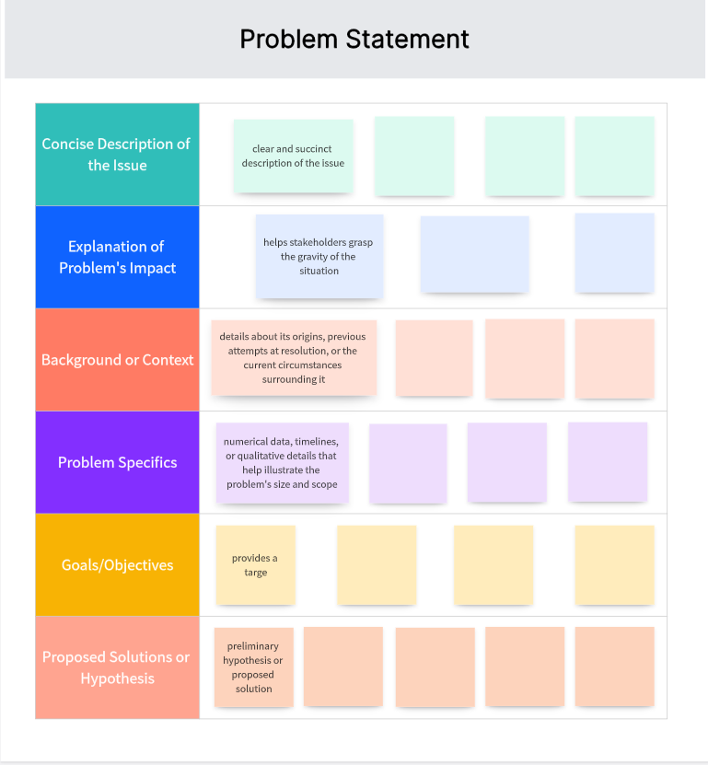

Step-2: Brainstorm, Idea Listing and Grouping
Once the problem was defined, brainstorming sessions were conducted to explore potential solutions. Each member contributed ideas that were recorded and grouped based on their relevance and feasibility. The following ideas emerged during the session:
- • Develop a ServiceNow catalog form for laptop requests.
- • Include approval workflows based on department hierarchy.
- • Integrate with asset inventory to check laptop availability.
- • Add real-time status notifications for request updates.
- • Implement a feedback mechanism after laptop issuance.
After discussion, the ideas were categorized into groups—Process Automation, User Experience, and IT Integration—for prioritization.
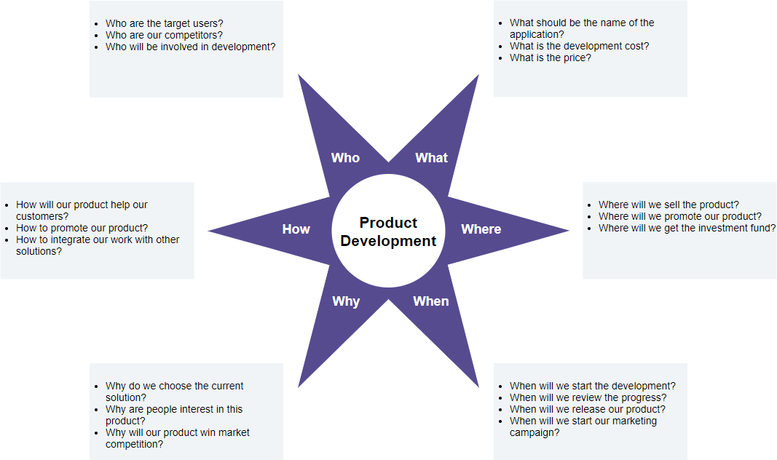

Step-3: Idea Prioritization
In this phase, the team evaluated and ranked the generated ideas based on criteria such as impact, cost, implementation time, and feasibility. The prioritization matrix helped determine which ideas should be implemented first to provide maximum benefit.
Top prioritized ideas included the development of an approval-based workflow and integration with inventory systems. These were chosen because they directly addressed the key challenges of delay and lack of transparency in the existing process.
